
Sukkur IBA University

Department of Computer Science
Circuit Analysis, spring 2024

Lab-07: Verification of Current Divider Rule (CDR) & Voltage Divider Rule (VDR)

Instructor: Engr. Asif Ali

Note: Submit this lab hand-out in the next lab with attached solved activities and exercises



Submission Profile

Name: M

Submission date:

Marks obtained:

Receiving authority name and signature:

Comments:

________________________________________________________________________________

Instructor Signature

Learning Objectives

- To get hands on practice to design & analyze the linear circuits on NI Elvis-II.
- To understand & verify the voltage divider circuits & current divider circuits.
- To design & solve circuits on Multisim software.
Lab Hardware & Software Required

- NI Elvis-II Kit
- Resistors
- Connecting wires
- PC
- Multisim
Background Theory

Electric Circuit:

A connection of various electric elements of an electric network forming a closed path is called an electric circuit.

Current Divider Circuits:

When circuit elements are connected in parallel, current through the circuit is divided into each individual element, whose magnitude depends on the ohmic value of an each element.
Current divider rule provides a useful relationship for determining the current through individual circuit elements that are connected in parallel.

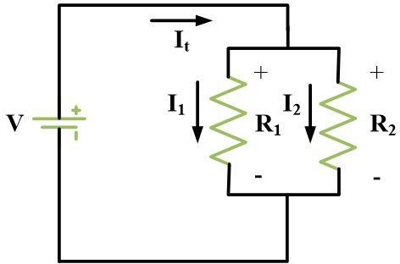
FIG. 1

In the circuit shown in Fig.1, Current 𝐼𝑡 is divided between the resistors 𝑅1 & 𝑅2. The current through each resistor 𝐼₁ & 𝐼₂ can be determined by the current division rule.

I₁= I_{t} x R₂ / (R₁+R₂) …..(1)
Similarly, for 𝐼₂;

I₂= I_{t} x R₁ / (R₁+R₂) …… (2)

Voltage Divider Rule:

Each resistor in a series combination has a different voltage drop across it depending upon its ohmic value. The individual voltage drop of resistors adds up to source voltage. However, current through the series circuit will remain same.

Voltage Divider Rule shows how the voltage distributes among different resistors in a series circuit.
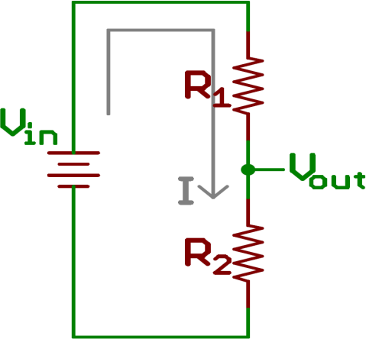

Fig.2

In the series circuit shown Fig.2, voltage is divided across resistors 𝑅1 & 𝑅2. The voltage across each resistor is 𝑉1 & 𝑉2 respectively and can be determined using a Voltage divider rule.

𝑽𝟏
= 𝑽

𝒊𝒏
× 𝑹𝟏 … (iii)
𝑹𝑻

𝑽𝟐

= 𝑽

𝒊𝒏
× 𝑹𝟐 … (iv)
𝑹𝑻

Lab Activities

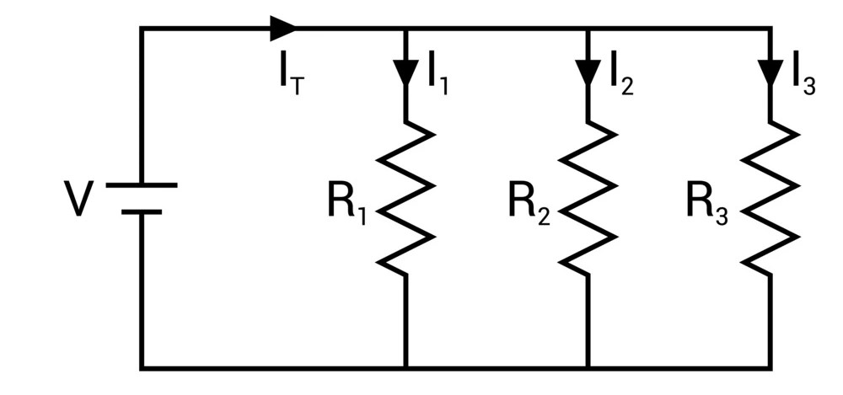Verification of Current Divider Rule:

FIG. 3

- Design the circuit consisting of four resistors & connect it with the 12-Volt DC source as shown in Fig. 3. Resistor ratings can be taken as per choice.
- Calculate the current though each parallel branch using a Current Divider rule & record the readings in Table.1 as given in Worksheet.
- Measure the current using an ammeter through each parallel branch & record the readings in Table.1 given in worksheet.

Verification of Voltage Divider Rule:

  - Design the series circuit shown in Fig.4. Resistor ratings can be taken as per choice.

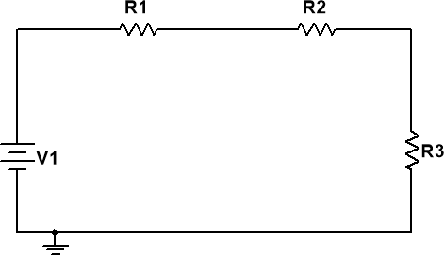
Fig. 4

  - Calculate the voltage across each resistor using a Voltage divider rule & record it in Table.2 as given in the worksheet.

WORKSHEET
Table 1

Total Voltages | Current | Resister  Measured | Current (mA) [Calculated] | Current (mA) [Measured]
12V | I₁ | R1=462 | 25.9 mA | 24.24 mA
12V | I₂ | R2=3220 | 3.725 mA | 3.51 mA
12V | I₃ | R3=3240 | 3.704 mA | 3.049 mA

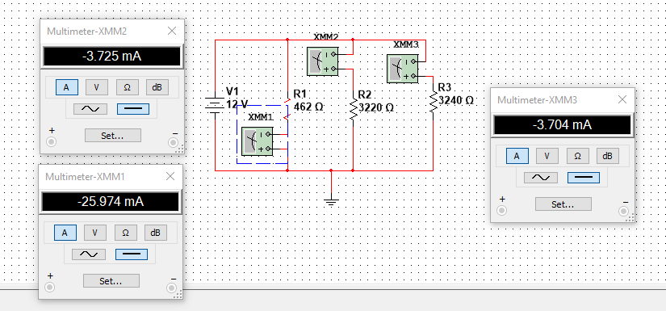

Table 2
Voltage | Voltage (V) [Calculated] | Voltage (V) [Measured]
V₁ | 0.800 V | 0.8V
V₂ | 5.58 V | 5.58V
V₃ | 5.616 V | 5.61V
Total Voltages | 12V

